Capture Moments-Aws powered Photographer booking system

## Project Description:

At Capture Moments Photography, the growing client base has created challenges in managing bookings and connecting customers with the right photographers. The manual booking process was inefficient and prone to errors, causing scheduling conflicts and customer dissatisfaction.

To solve this, Capture Moments developed a cloud-based Photographer Booking Platform. Using Flask for backend development, AWS EC2 for hosting, and DynamoDB for managing data, the system allows clients to register, log in, and book photographers online. This cloud-based solution enhances the booking experience, providing seamless service for all clients while optimizing photographer scheduling and data management.

**Scenario 1: Efficient Booking System for Clients**

In the Capture Moments Booking Platform, AWS EC2 ensures a reliable infrastructure to manage multiple clients accessing the platform simultaneously. For example, a client can log in, navigate to the booking page, and easily submit a request for their preferred photographer. Flask handles backend operations, efficiently retrieving and processing user data in real-time. The cloud-based architecture allows the platform to handle a high volume of booking requests during peak wedding seasons, ensuring smooth operation without delays.

**Scenario 2: Centralized Booking Management**

When clients book photography sessions, the Capture Moments Booking System processes these requests through a streamlined workflow. For instance, a client books a wedding photographer, and Flask processes the request, storing all the booking details securely in DynamoDB. This centralized database approach ensures all booking information is maintained in a single source of truth, allowing administrative staff to track upcoming appointments, manage photographer schedules, and maintain complete records of client preferences and requirements.

**Scenario 3: Easy Access to Photography Services**

The Capture Moments Booking Platform provides clients with easy access to available photographers and packages. For example, a client logs in and views the list of available photographers specializing in their event type. They can quickly check availability for specific dates or book immediately. Flask manages real-time data fetching from DynamoDB, while EC2 hosting ensures the platform performs seamlessly even when multiple clients access it simultaneously during popular booking periods, offering a smooth and uninterrupted user experience.

AWS ARCHITECTURE

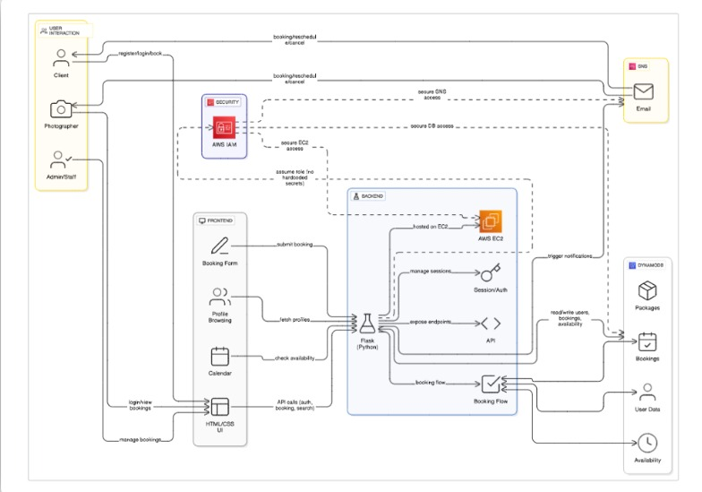

Entity Relationship (ER)Diagram:

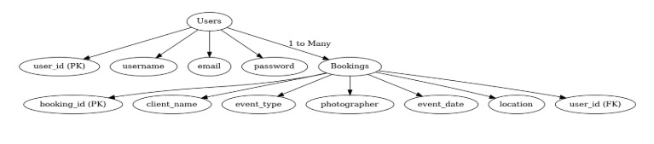

## Pre-requisites:

1. .**AWS Account Setup**: [AWS Account Setup](https://youtu.be/CjKhQoYeR4Q?si=ui8Bvk_M4FfVM-Dh)
2. **Understanding IAM**: [IAM Overview](https://youtu.be/gsgdAyGhV0o?si=3qg-bULgkD4LXNvR)
3. **Amazon EC2 Basics**: [EC2 Tutorial](https://youtu.be/8TlukLu11Yo?si=MUj0nEAOESRhHUIz)
4. **DynamoDB Basics**: [DynamoDB Introduction](https://docs.aws.amazon.com/dynamodb)
5. **Git Version Control**: [Git Documentation](https://git-scm.com/doc)

## Project WorkFlow:

### AWS Account Setup and Login

**Activity 1.1:** Set up an AWS account if not already done**.** **Activity 1.2:** Log in to the AWS Management Console

### DynamoDB Database Creation and Setup

**Activity 2.1**: Create a DynamoDB Table.

**Activity 2.2**: Configure Attributes for User Data and Book Requests.

### Backend Development and Application Setup

**Activity 3.1**:Develop the Backend Using Flask.

**Activity 3.2**: Integrate AWS Services Using boto3.

### IAM Role Setup

**Activity 4.1**: Create IAM Role

**Activity 4.2**: Attach Policies

### EC2 Instance Setup

**Activity 5.1**: Launch an EC2 instance to host the Flask application.

**Activity 5.2**: Configure security groups for HTTP, and SSH access.

1. **Deployment on EC2 Activity 6.1**:Upload Flask Files **Activity 6.2**: Run the Flask App

### 7.Testing and Deployment

**Activity 7.1**: Conduct functional testing to verify user registration, login, book requests.

# Milestone 1: AWS Account Setup and Login

### Activity 1.1: Set up an AWS account if not already done.

* + - Sign up for an AWS account and configure billing settings.

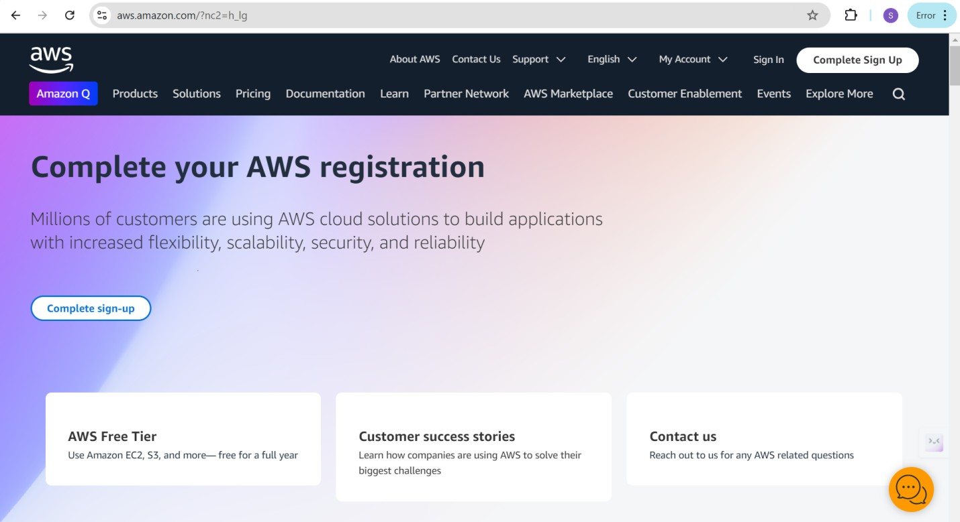

### Activity 1.2: Log in to the AWS Management Console

* + - After setting up your account, log in to the [AWS Management Console](https://aws.amazon.com/console/).

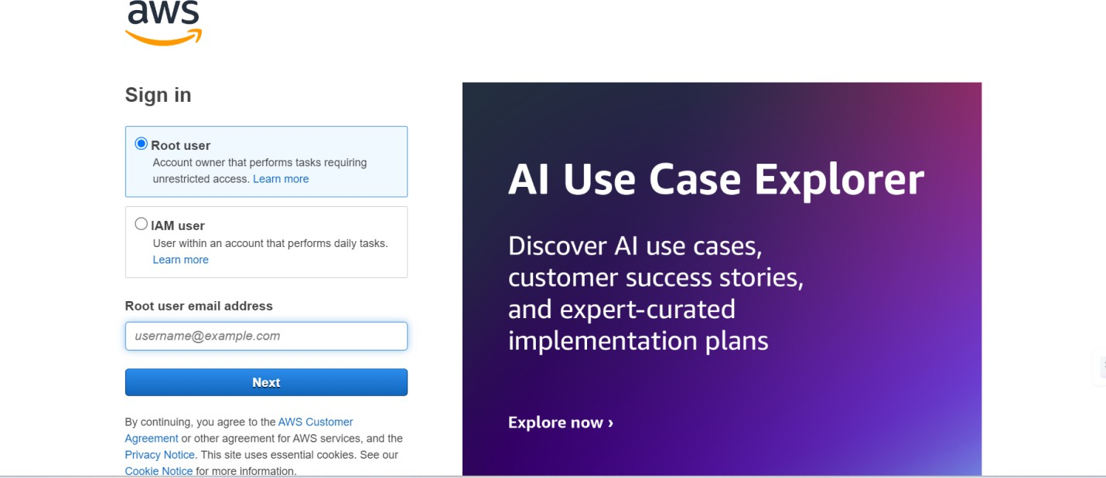

# Milestone 2: DynamoDB Database Creation and Setup

### Activity 2.1:Navigate to the DynamoDB

* + - In the AWS Console, navigate to DynamoDB and click on create tables.

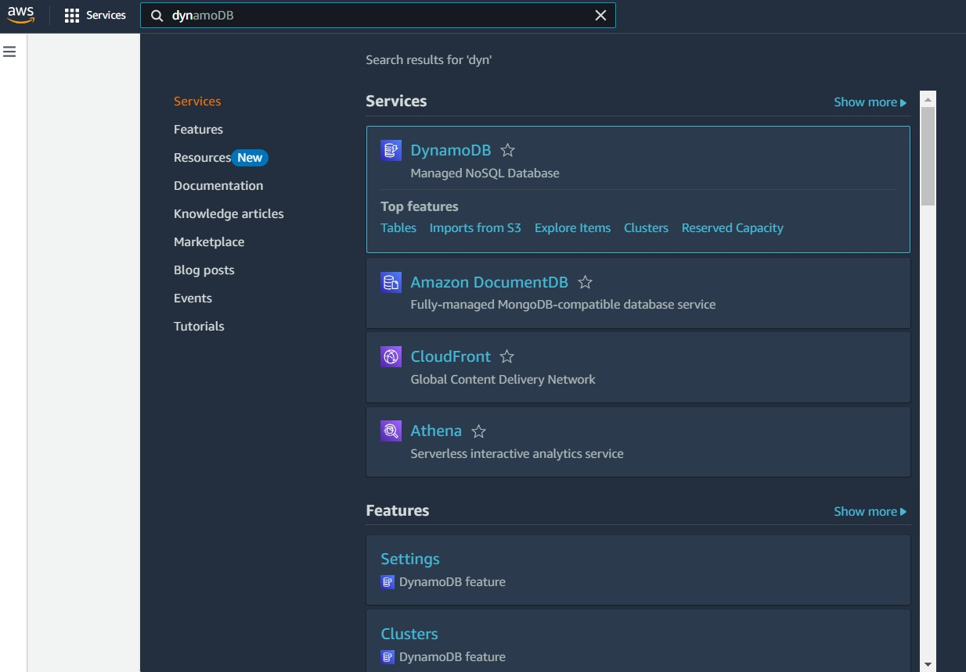

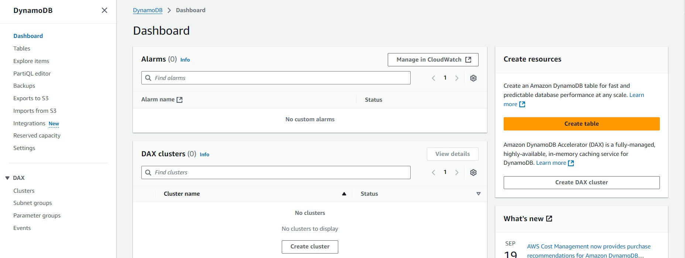

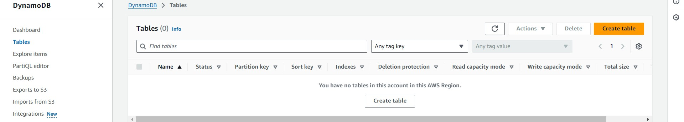

### Activity 2.2:Create a DynamoDB table for storing registration details and book requests.

* + - Create photographers table with partition key “photographer_id” with type String and click on create tables.

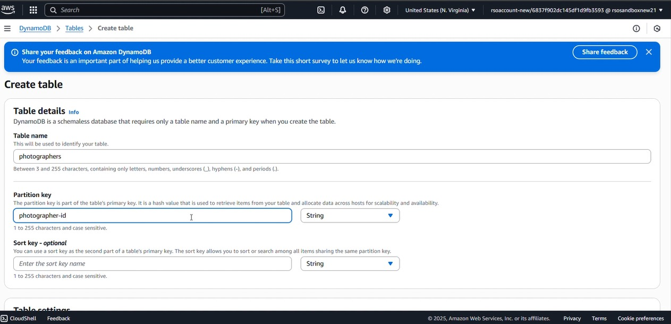

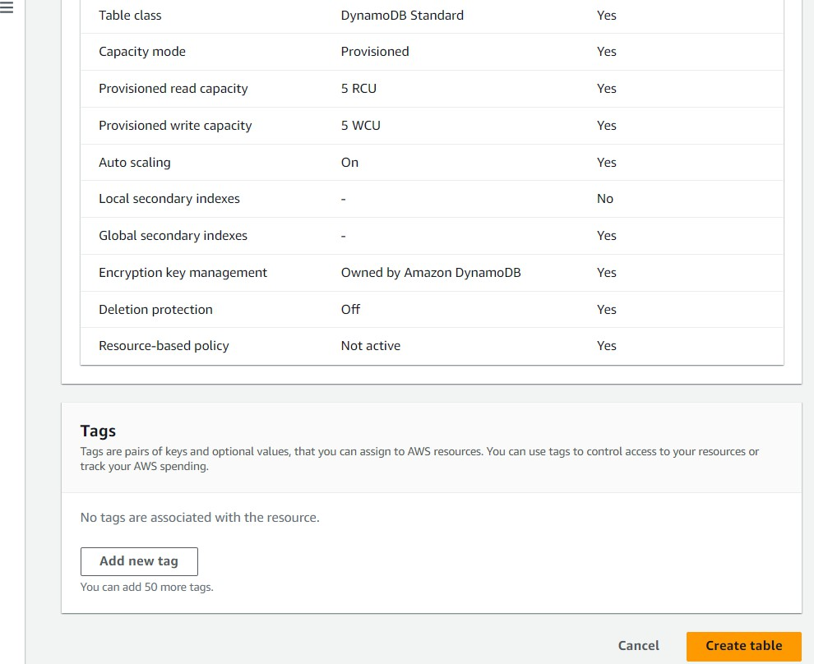

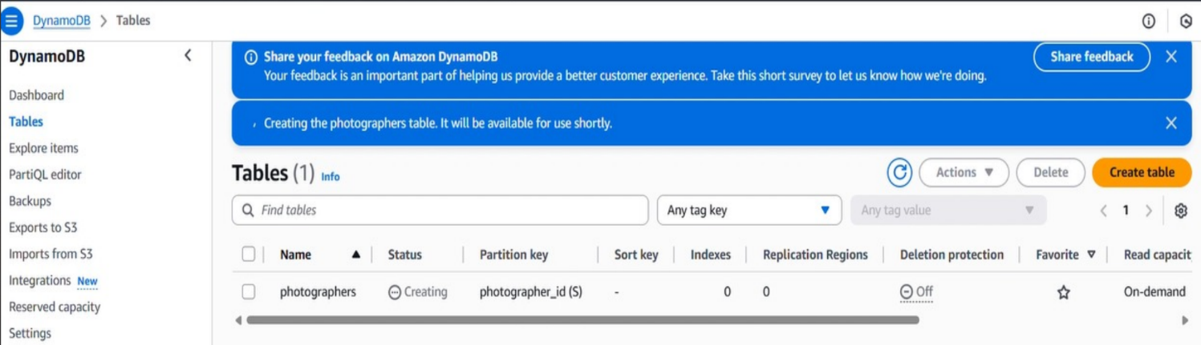

* + - Follow the same steps to create a requests table with photographer_id as the primary key for book requests data.

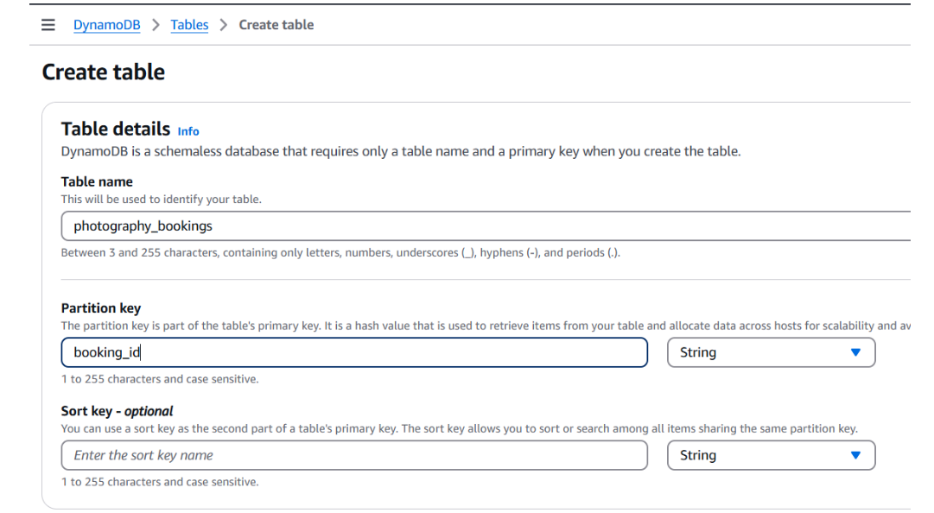

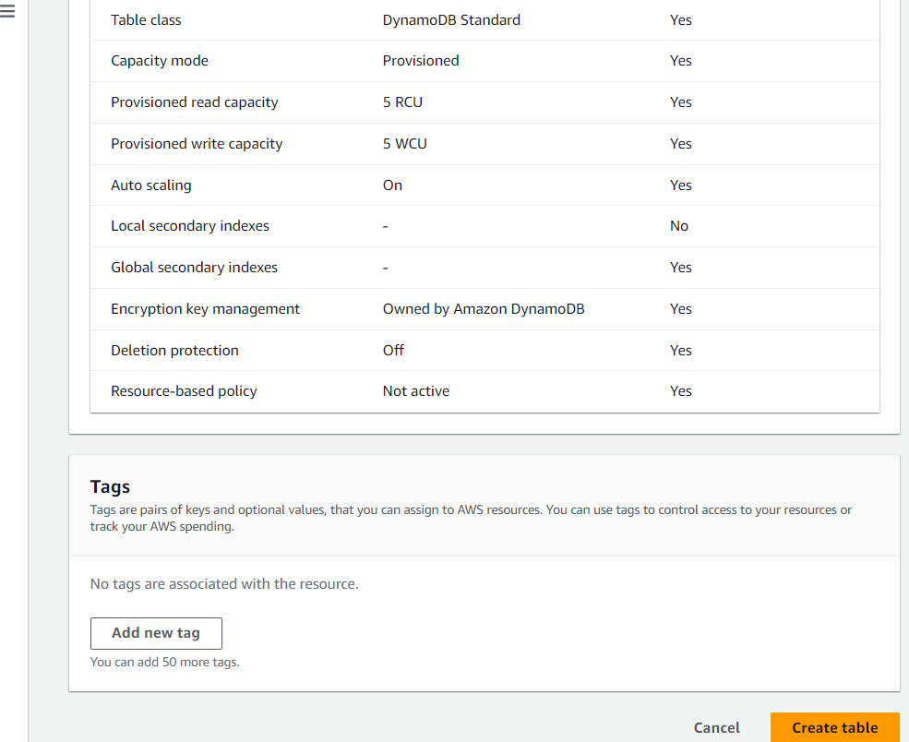

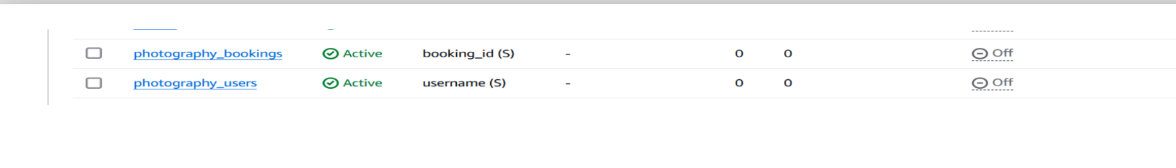

# Milestone 3:Backend Development and Application Setup

### Activity 3.1: Develop the backend using Flask

* + File Explorer Structure

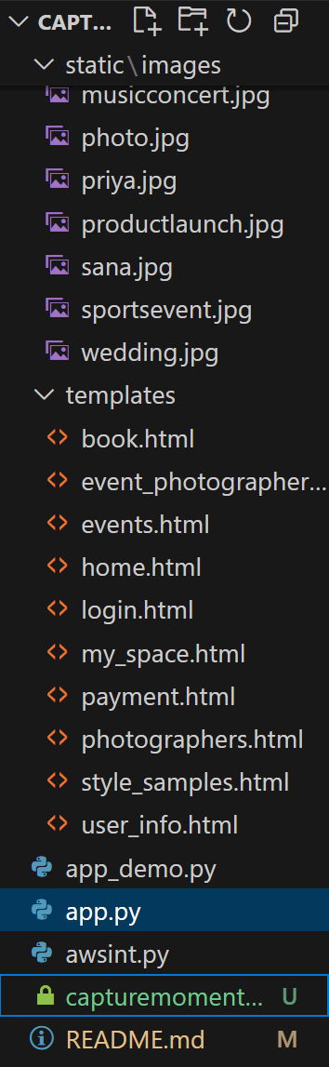

**Description:** set up the INSTANT LIBRARY project with an app.py file, a static/ folder for assets, and a templates/ directory containing all required HTML pages like home, login, register, subject-specific pages (e.g., computer_science.html, data_science.html), and utility pages (e.g., request-form.html, statistics.html).

## Description of the code :

### Flask App Initialization

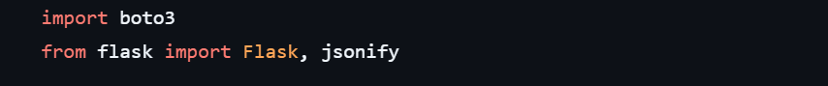

**Description:** import essential libraries including Flask utilities for routing, Boto3 for DynamoDB operations.



**Description:** initialize the Flask application instance using Flask( name ) to start building the web app.

### Dynamodb Setup:

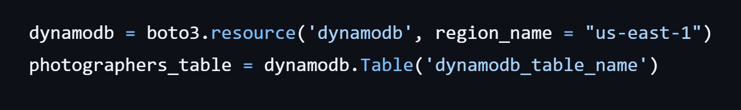

**Description:** initialize the DynamoDB resource for the us-east-1 region and set up access to the photographers table for storing details.

## Routes for Web Pages

### Home Route:

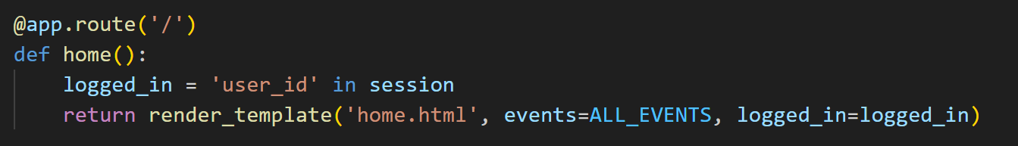

**Description:** Loads the homepage with a list of all events. Checks if the user is logged in via session and displays relevant UI options.

* **Login Route:**

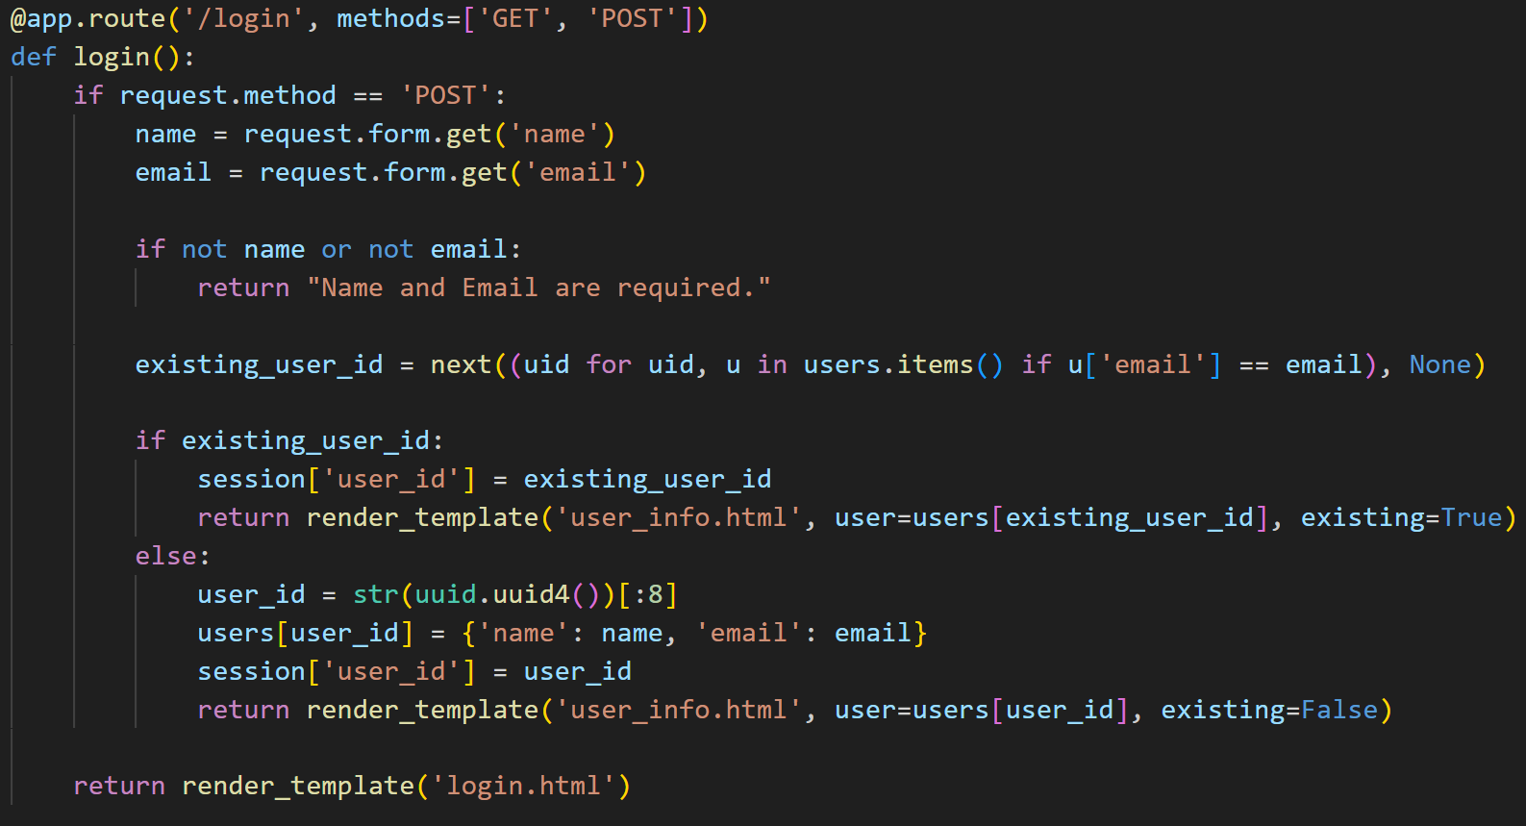

**Description:** Handles both login and registration from a single form.

If the email already exists, logs in the user and shows their info.

If new, generates a new user_id and stores user details in memory.

* **User Info / My Space Route:**

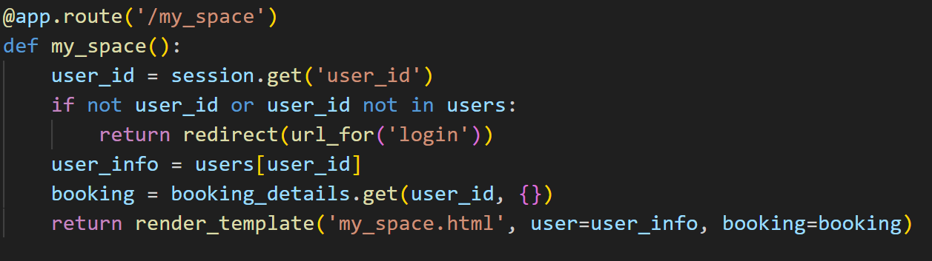

**Description:**  
Displays the logged-in user’s personal info and booking details if available. Redirects to login if not authenticated.

* **Logout Route:**

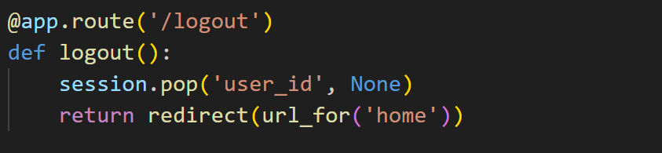

**Description:** Clears the session data and redirects the user to the homepage.

* **Choose Event Route:**

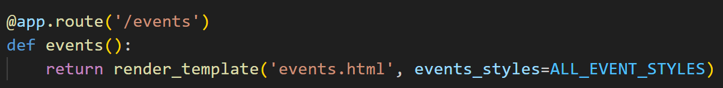

**Description:** Displays a grid of available events and their photography styles (like Candid, Traditional, Outdoor).

* **Photographers by Event Route:**

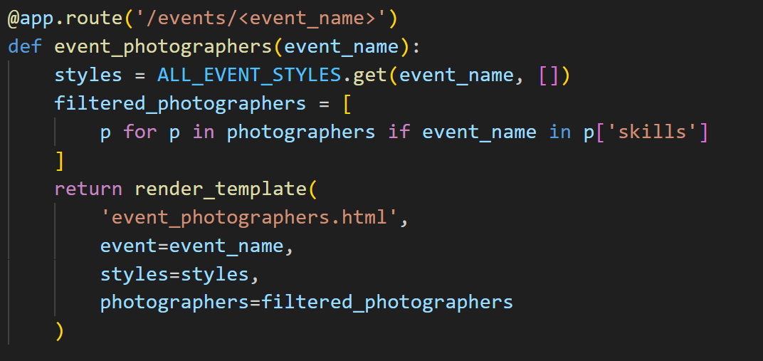

**Description:** Shows all photographers skilled in the selected event type, along with style buttons.

* **Photography Style Samples Route:**

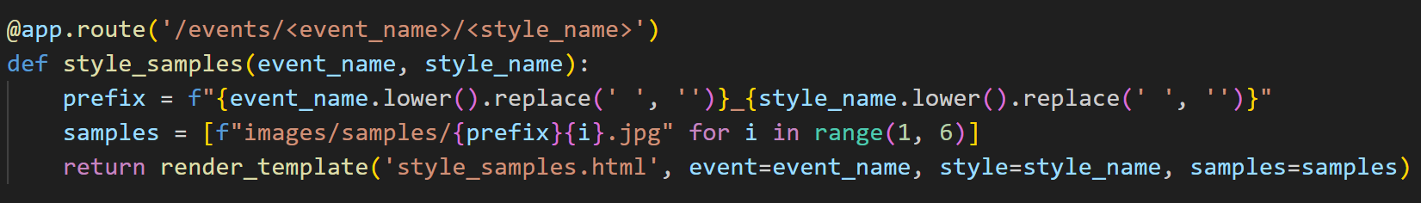

**Description:** Displays 5 sample images for the selected style of a given event.

* **Booking Route:**

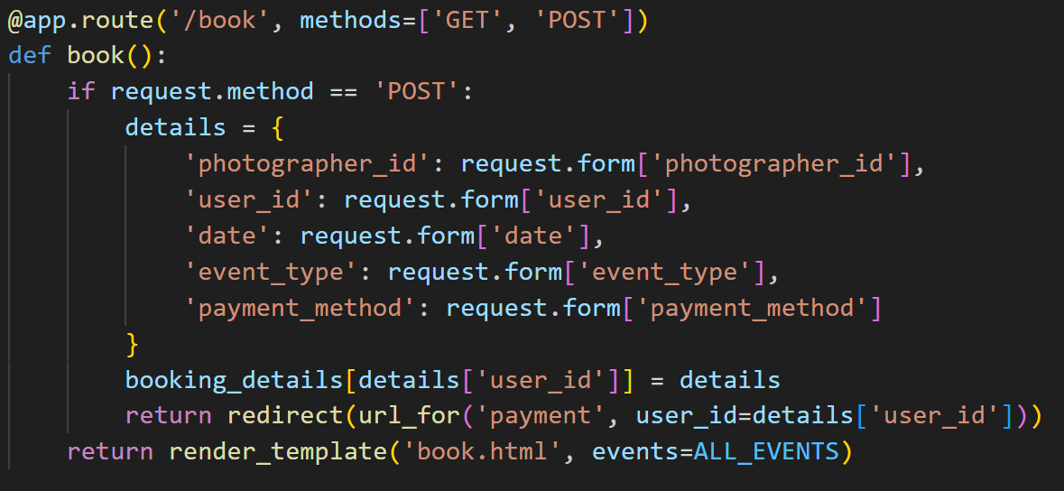

**Description:** Lets users fill out a form to book a photographer. On successful submission, redirects to payment.

* **All Photographers Route:**



**Description:** Displays all photographers and their available dates. Useful for browsing without selecting an event first.

* **Payment Page Route:**

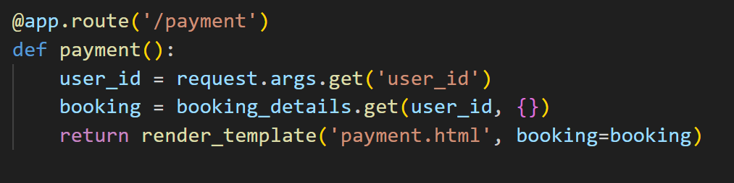

**Description:** Shows payment confirmation details for the user's recent booking.

**Deployment Code:**

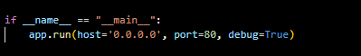

**Description:** start the Flask server to listen on all network interfaces (0.0.0.0) at port 80

with debug mode enabled for development and testing.

# Milestone 5: IAM Role Setup

### Activity 5.1:Create IAM Role.

* + In the AWS Console, go to IAM and create a new IAM Role for EC2 to interact with DynamoDB and SNS.

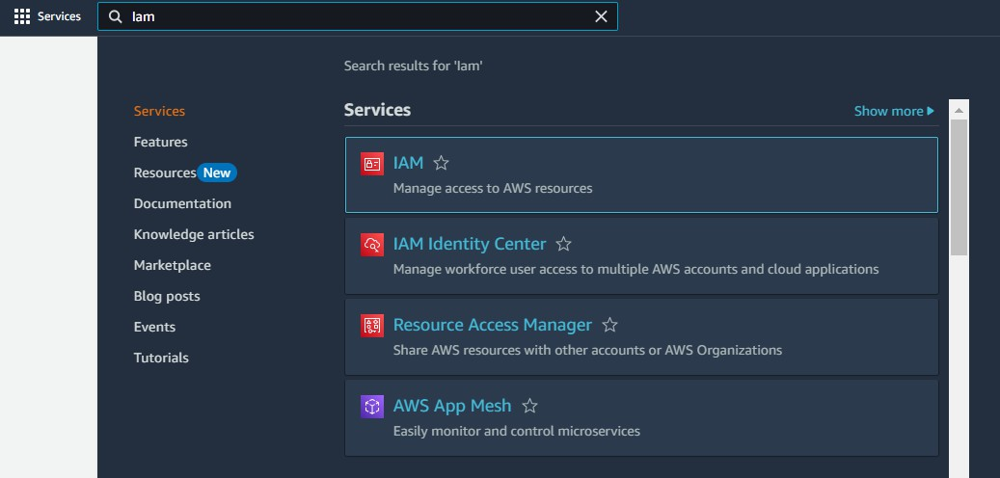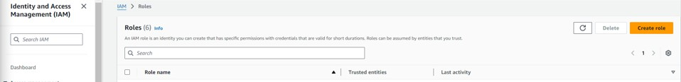

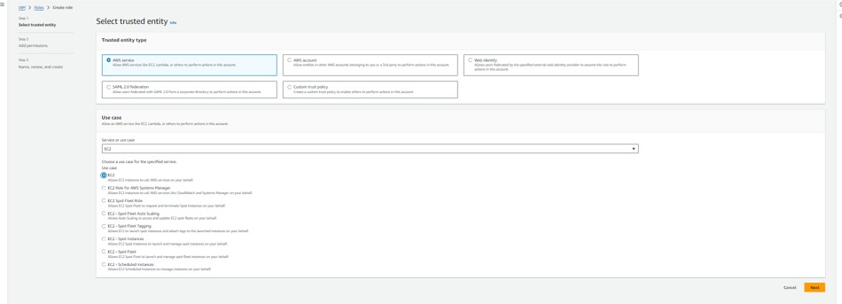

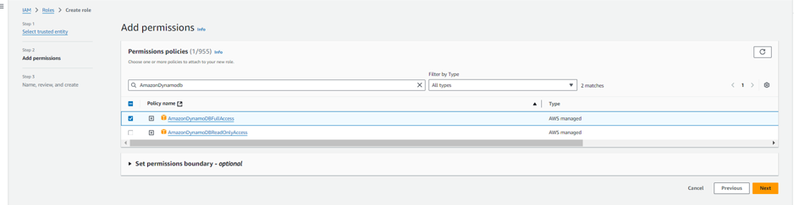

### Activity 5.2: Attach Policies.

Attach the following policies to the role:

* AmazonDynamoDBFullAccess: Allows EC2 to perform read/write operations on DynamoDB.
* AmazonSNSFullAccess: Grants EC2 the ability to send notifications via SNS.

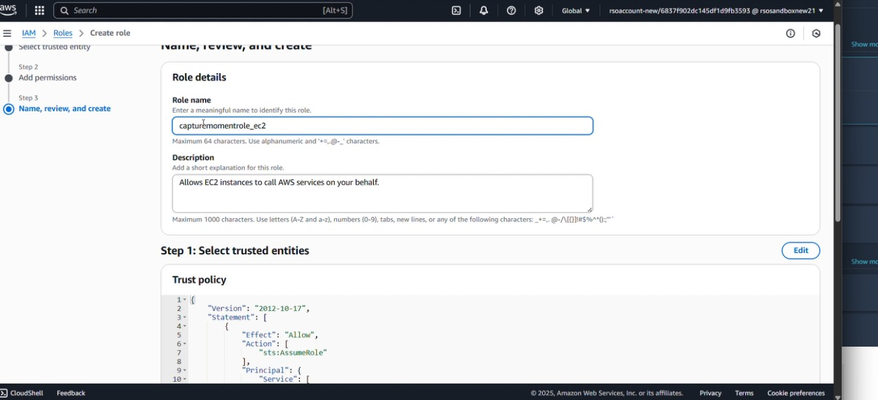

# Milestone 6: EC2 Instance Setup

* **Note: Load your Flask app and Html files into GitHub repository.**

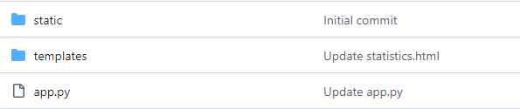

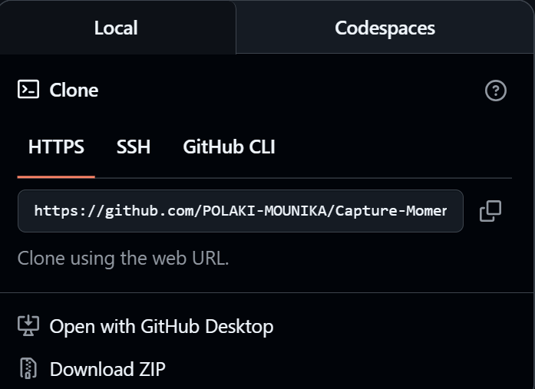

### Activity 5.1: Launch an EC2 instance to host the Flask application.

* + **Launch EC2 Instance**
    - In the AWS Console, navigate to EC2 and launch a new instance.

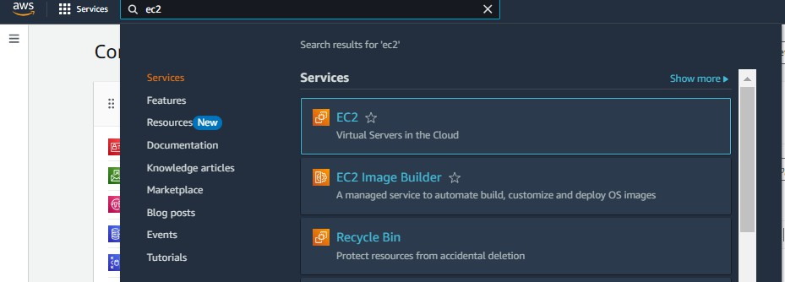

* Click on Launch instance to launch EC2 instance

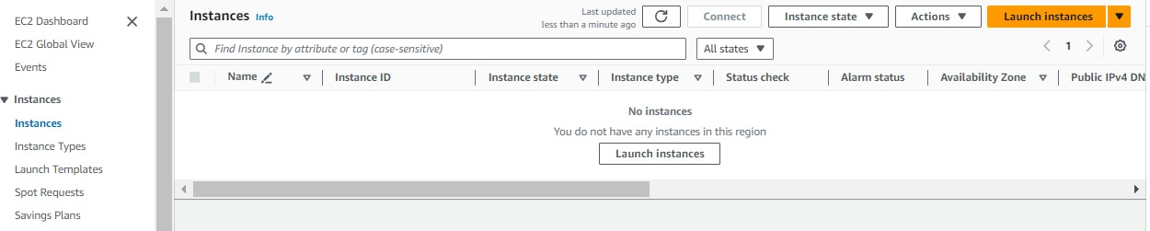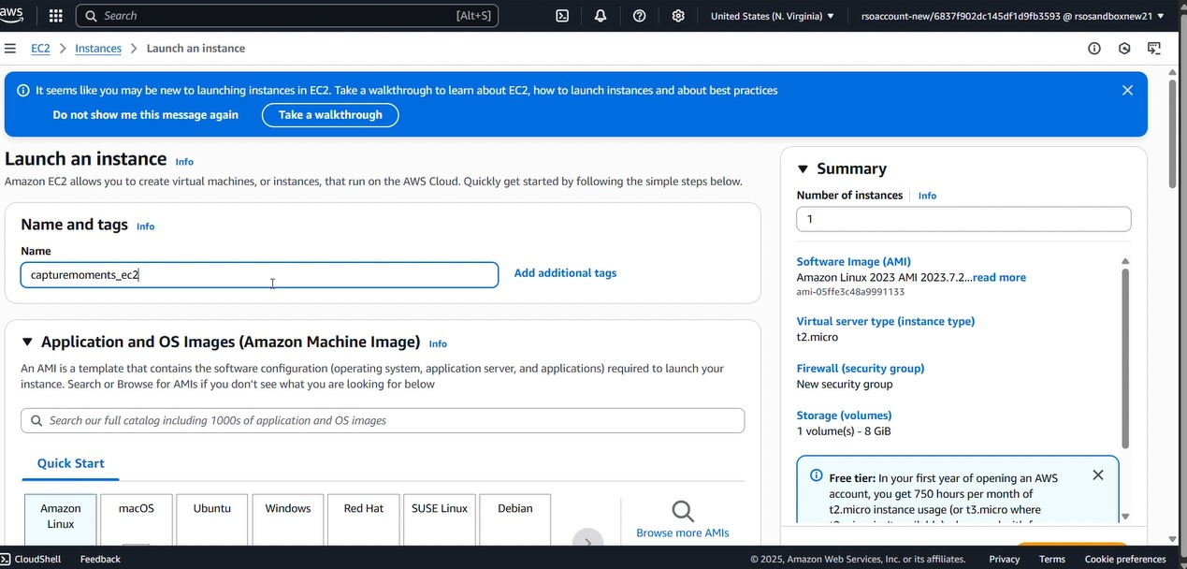

* + Choose Amazon Linux 2 or Ubuntu as the AMI and t2.micro as the instance type (free-tier eligible).

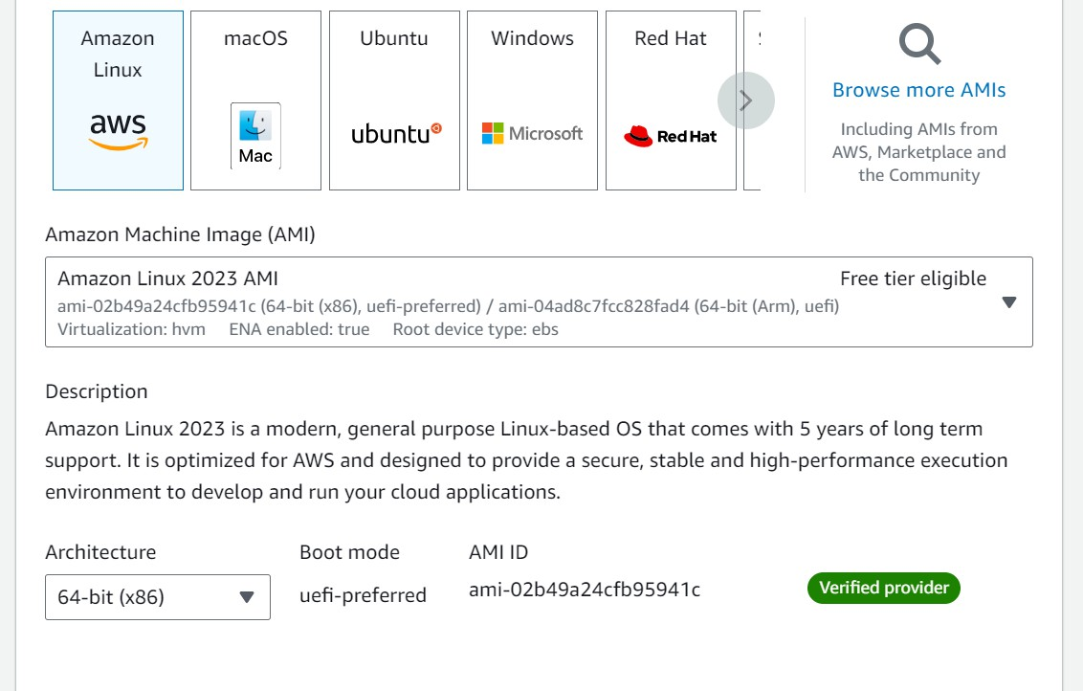

* Create and download the key pair for Server access.

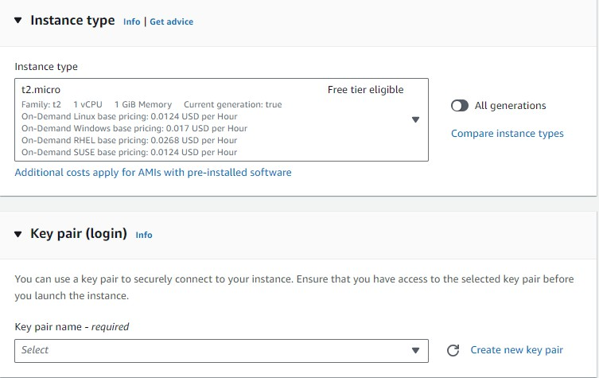

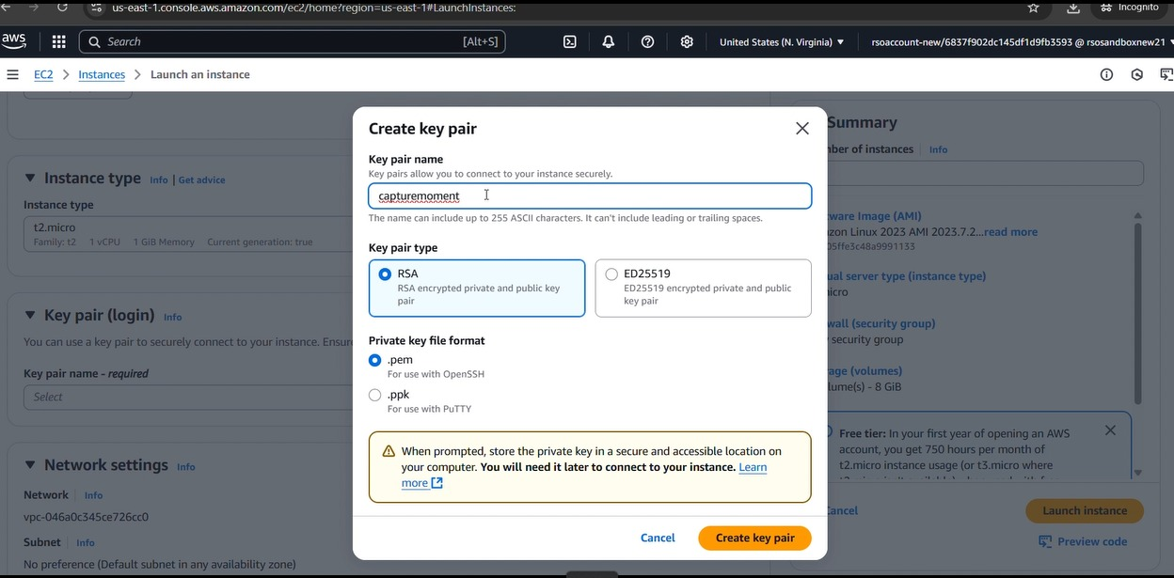

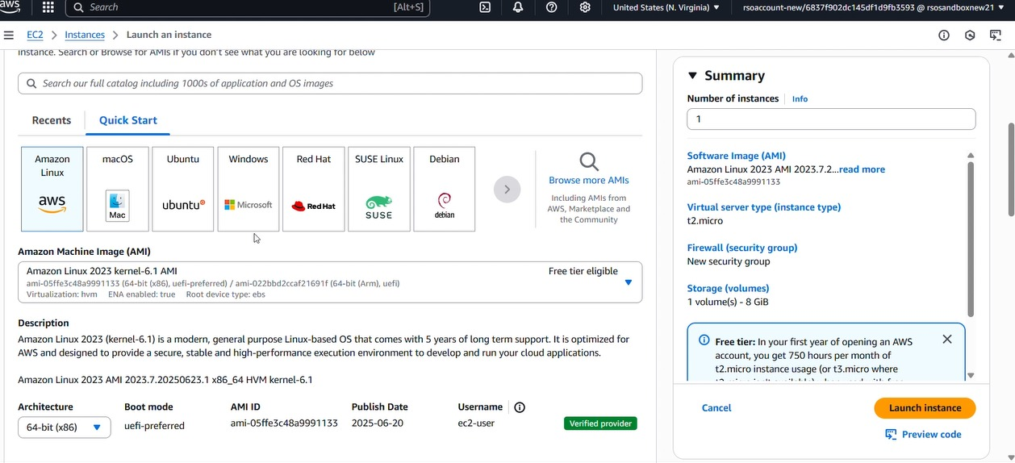

### Activity 5.2:Configure security groups for HTTP, and SSH access.

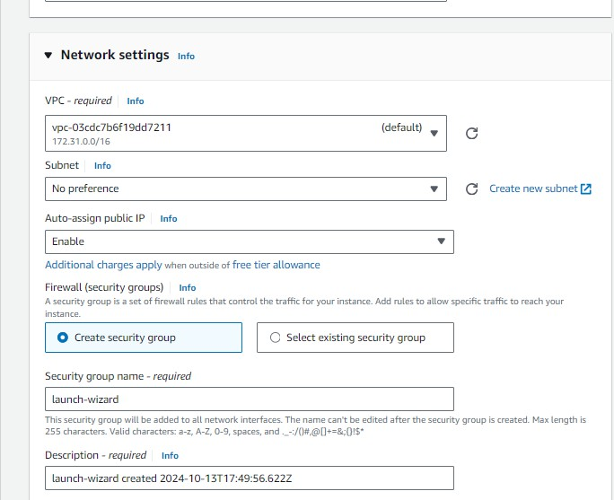

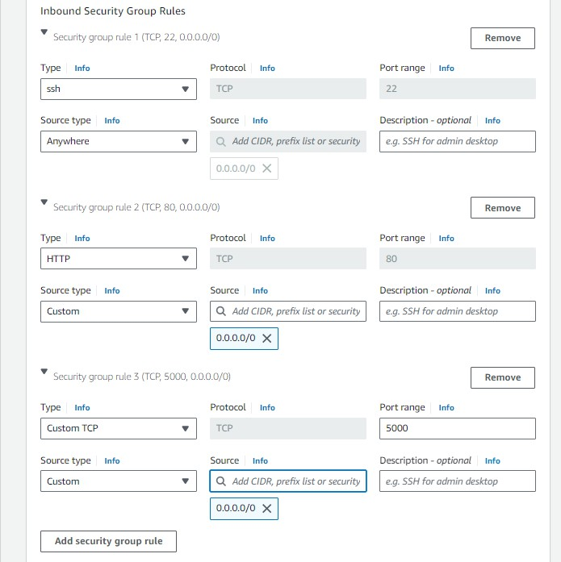

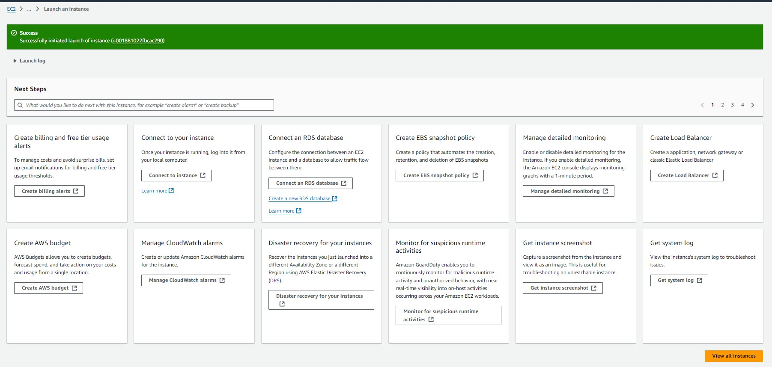

* To connect to EC2 using **EC2 Instance Connect**, start by ensuring that an **IAM role** is attached to your EC2 instance. You can do this by selecting your instance, clicking on **Actions**, then navigating to **Security** and selecting **Modify IAM Role** to attach the appropriate role. After the IAM role is connected, navigate to the **EC2** section in the **AWS Management Console**. Select the **EC2 instance** you wish to connect to. At the top of the **EC2 Dashboard**, click the **Connect** button. From the connection methods presented, choose **EC2 Instance Connect**. Finally, click **Connect** again, and a new browser-based terminal will open, allowing you to access your EC2 instance directly from your browser.

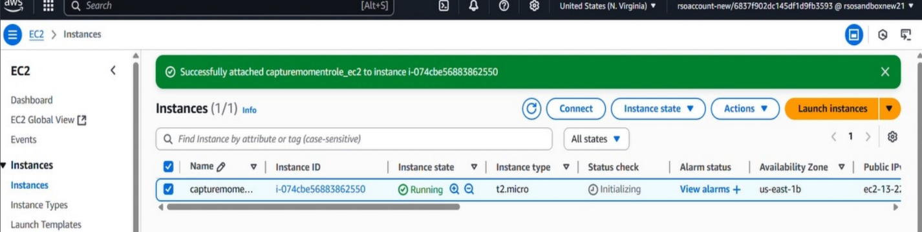

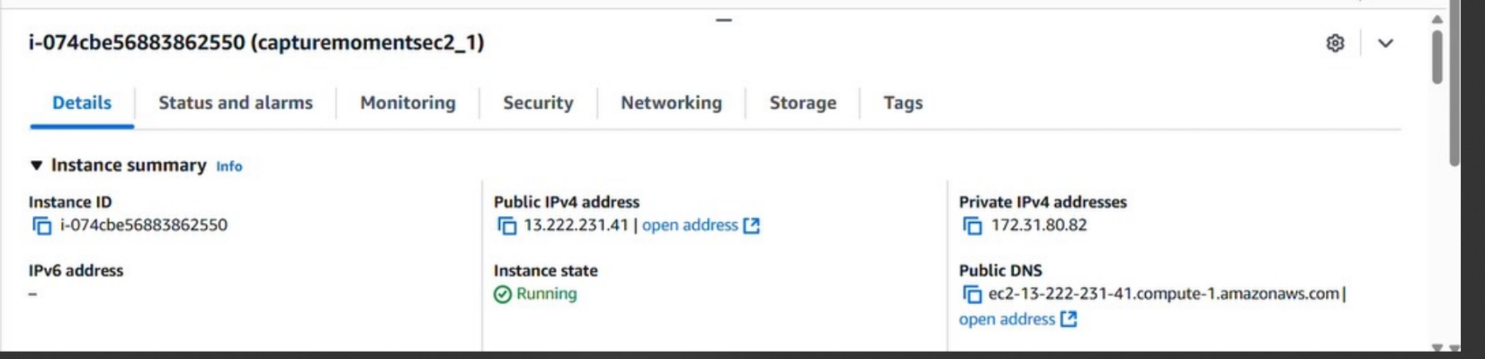

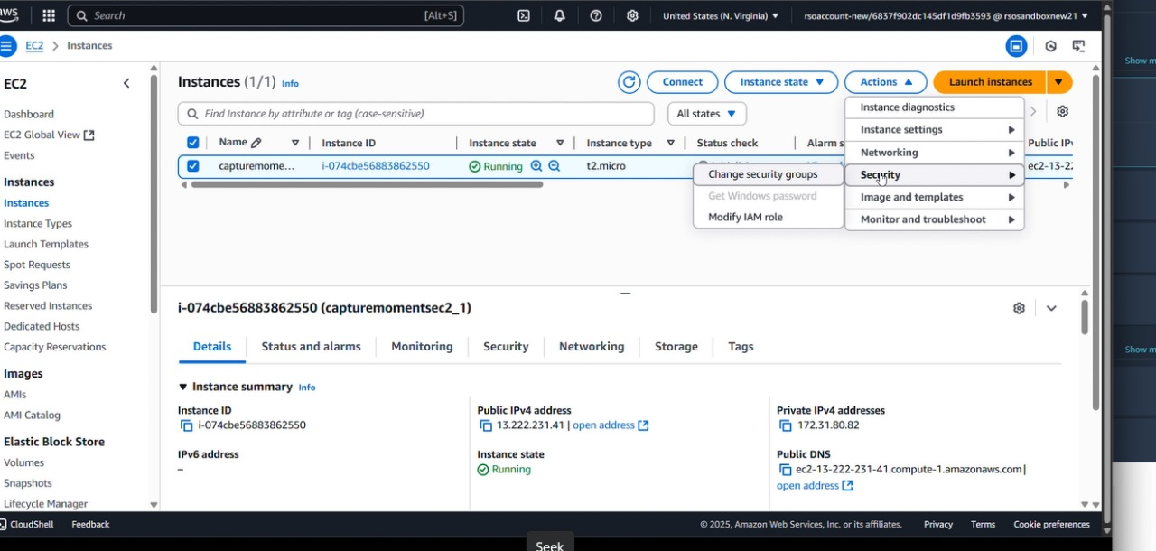

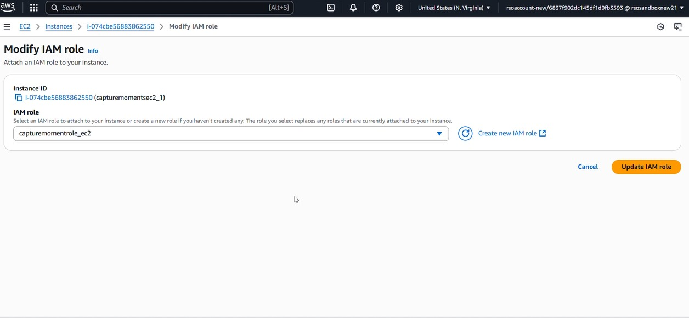

* Now connect the EC2 with the files

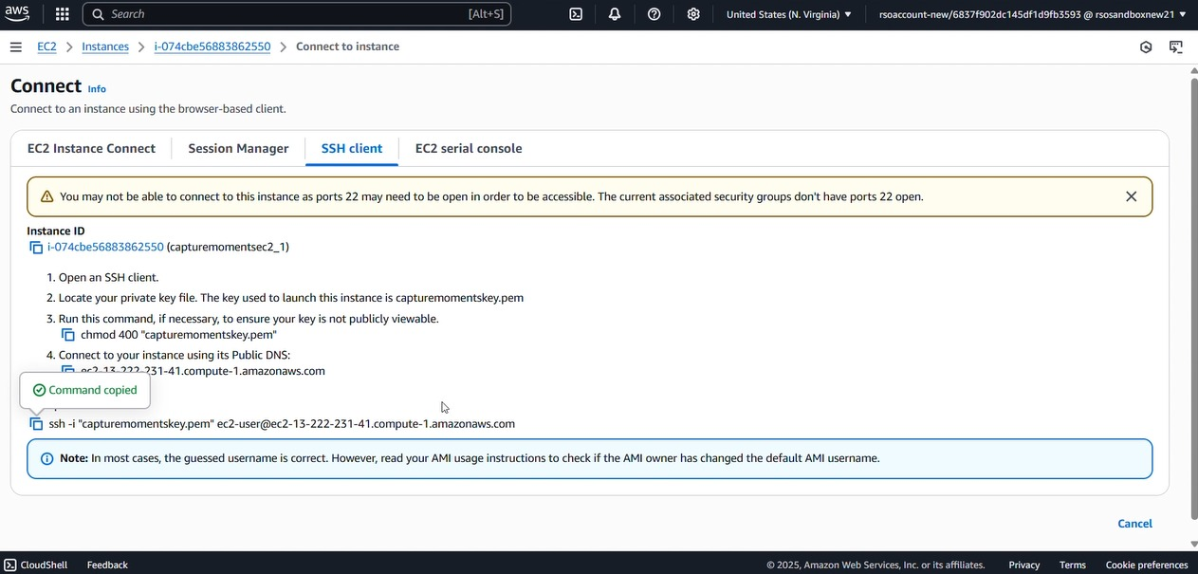

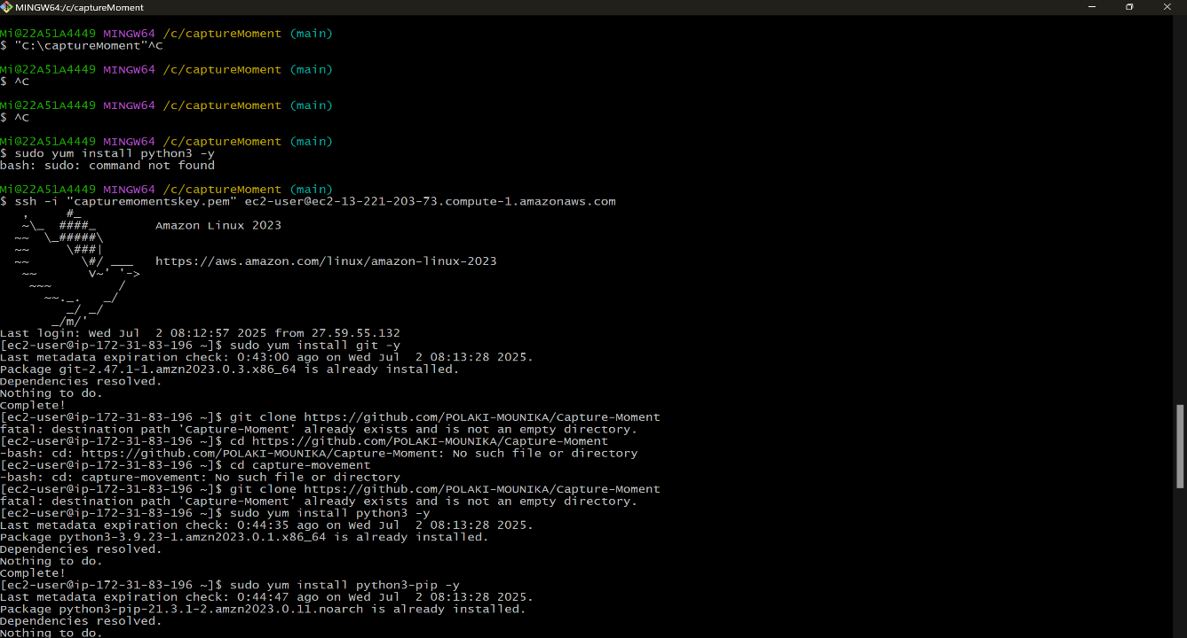

**Milestone 6: Deployment on EC2**

### Activity 6.1: Install Software on the EC2 Instance

Install Python3, Flask, and Git: On Amazon Linux 2:

sudo yum update -y

sudo yum install python3 git sudo pip3 install flask boto3

Verify Installations:

flask --version git --version

### Activity 6.2:Clone Your Flask Project from GitHub

**Clone your project repository from GitHub into the EC2 instance using Git.**

Run: ‘git clone <https://github.com/your-github-username/your-repository-name.git>’

Note: change your-github-username and your-repository-name with your credentials here: ‘git clone https://github.com/POLAKI-MOUNIKA/Capture-Moment.git ‘

* This will download your project to the EC2 instance.

### To navigate to the project directory, run the following command:

cd captureMoment

### Once inside the project directory, configure and run the Flask application by executing the following command with elevated privileges:

**Run the Flask Application**

sudo flask run --host=0.0.0.0 --port=80

### Access the website through:

**PublicIPs:** [**http://172.31.83.196:5000**](http://172.31.83.196:5000)

## Milestone 7: Testing and Deployment

Activity 7.1: Conduct functional testing to verify user registration, login, book requests.

* **Home Page:**

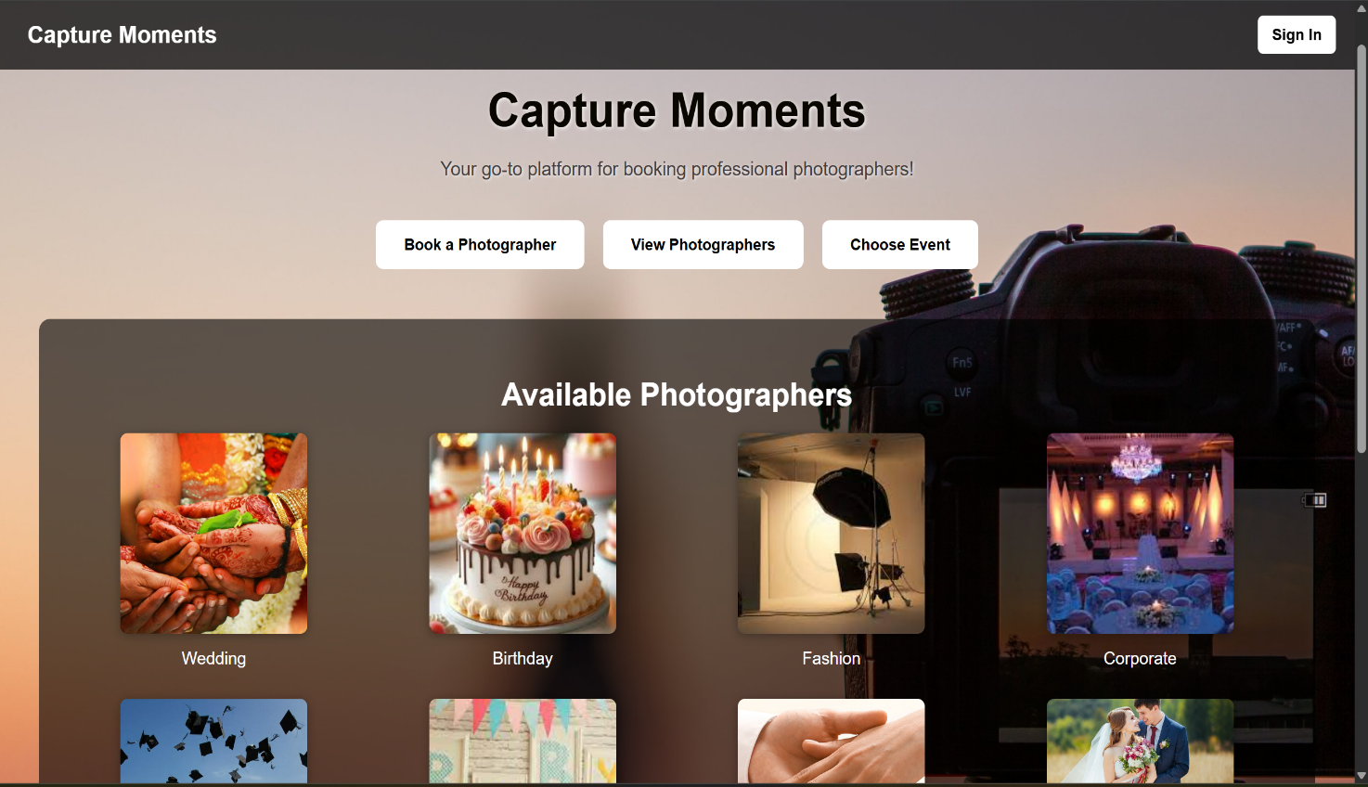

* **Signin Page:**

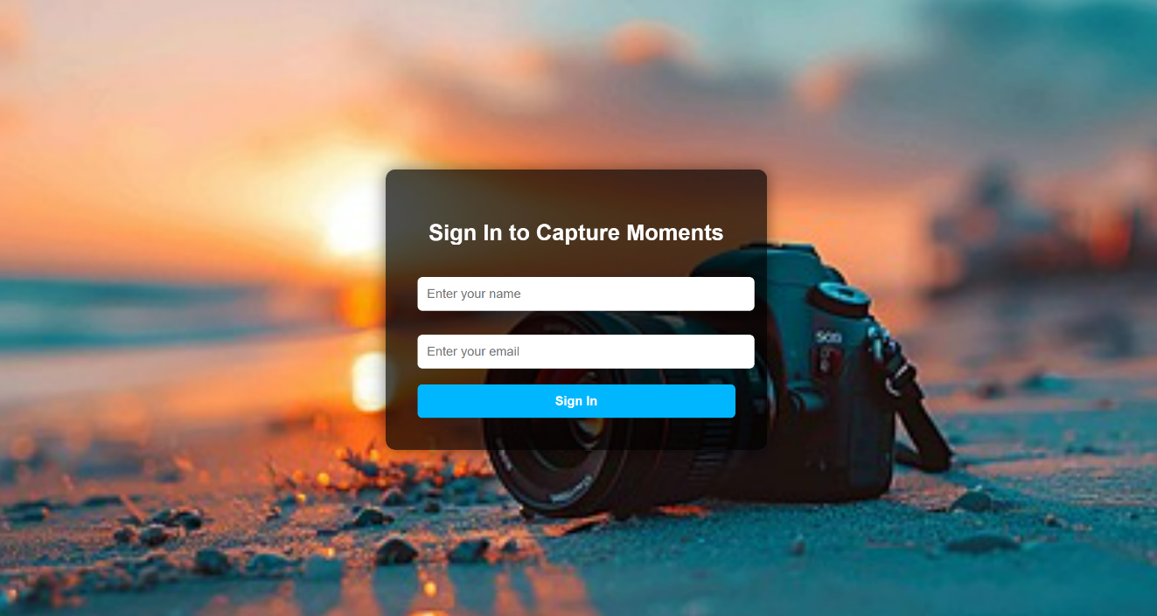

* **User_info page:**

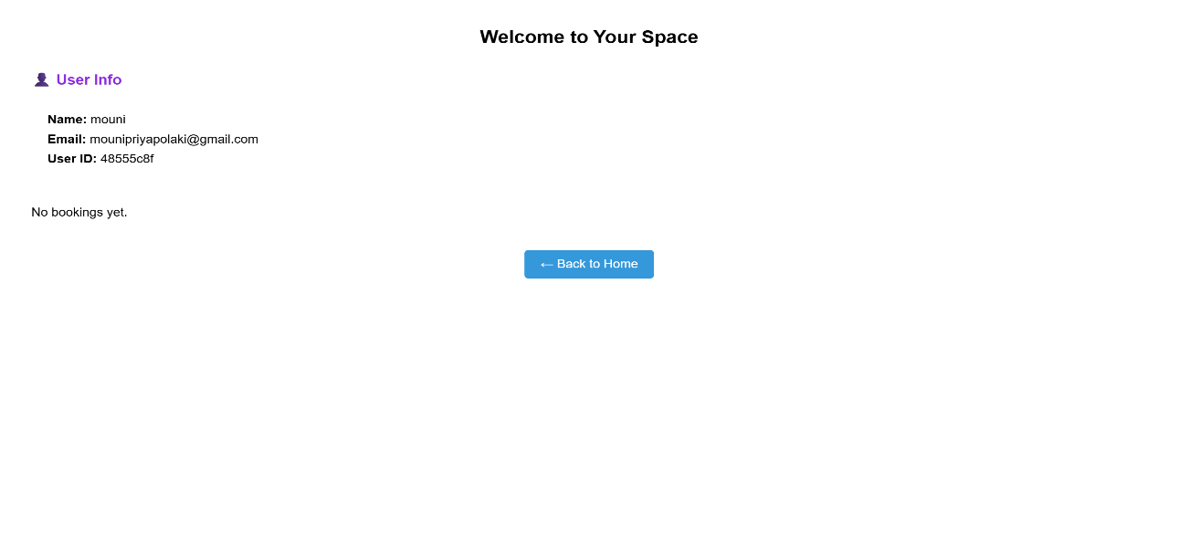

* **Book photographer page:**

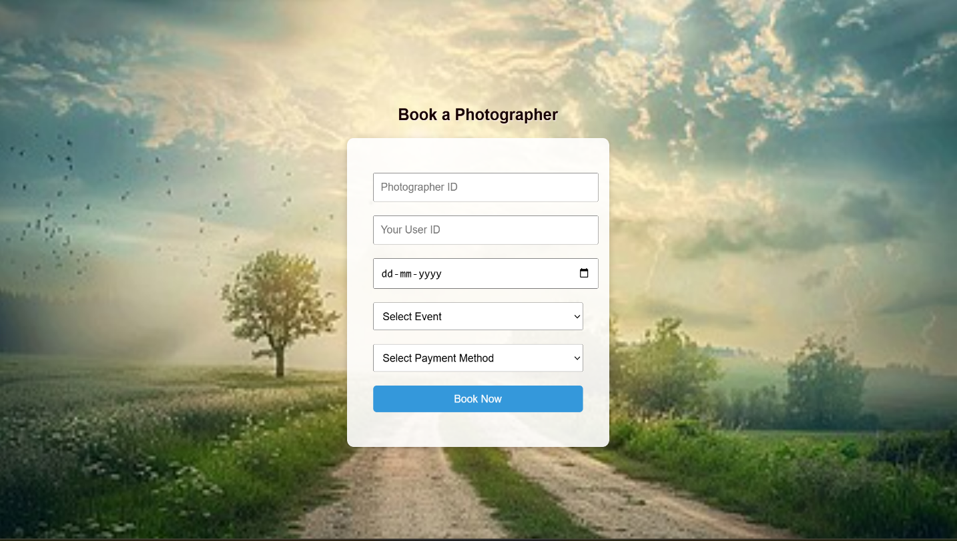

* **Choose event page:**

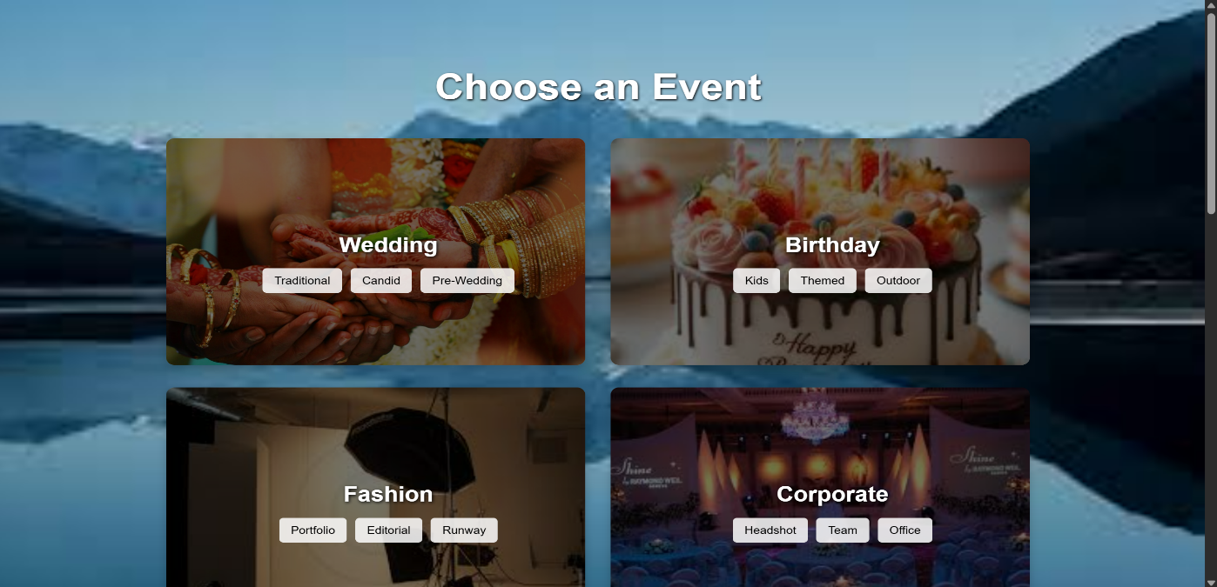

* **Event Photographer page:**

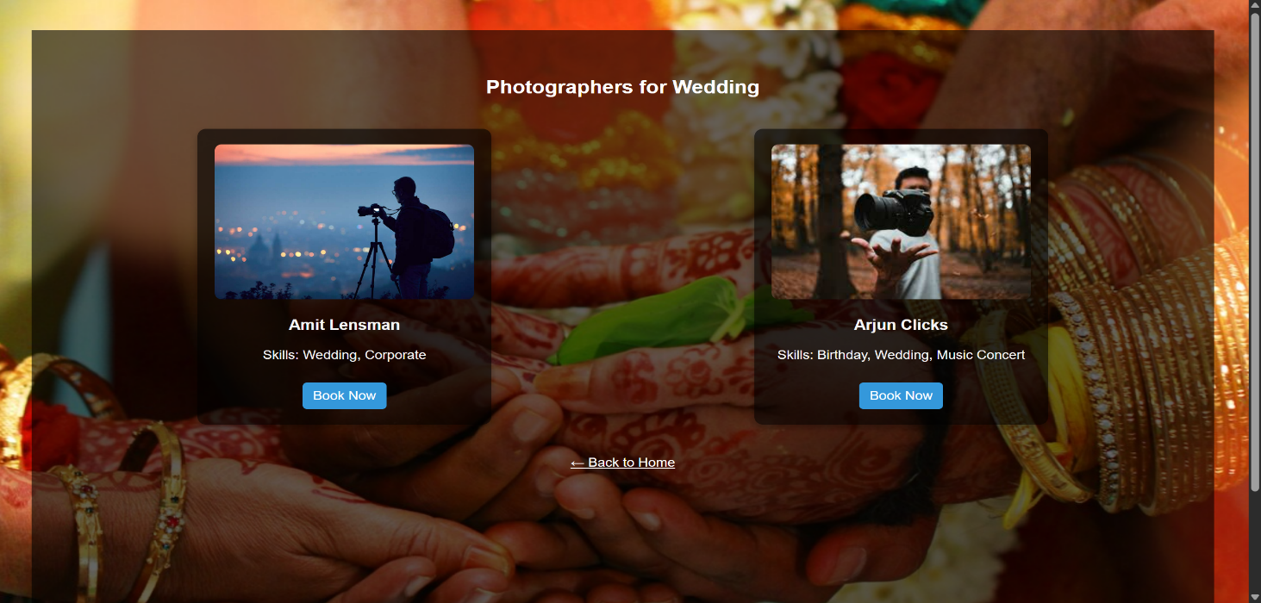

* **Photographers page:**

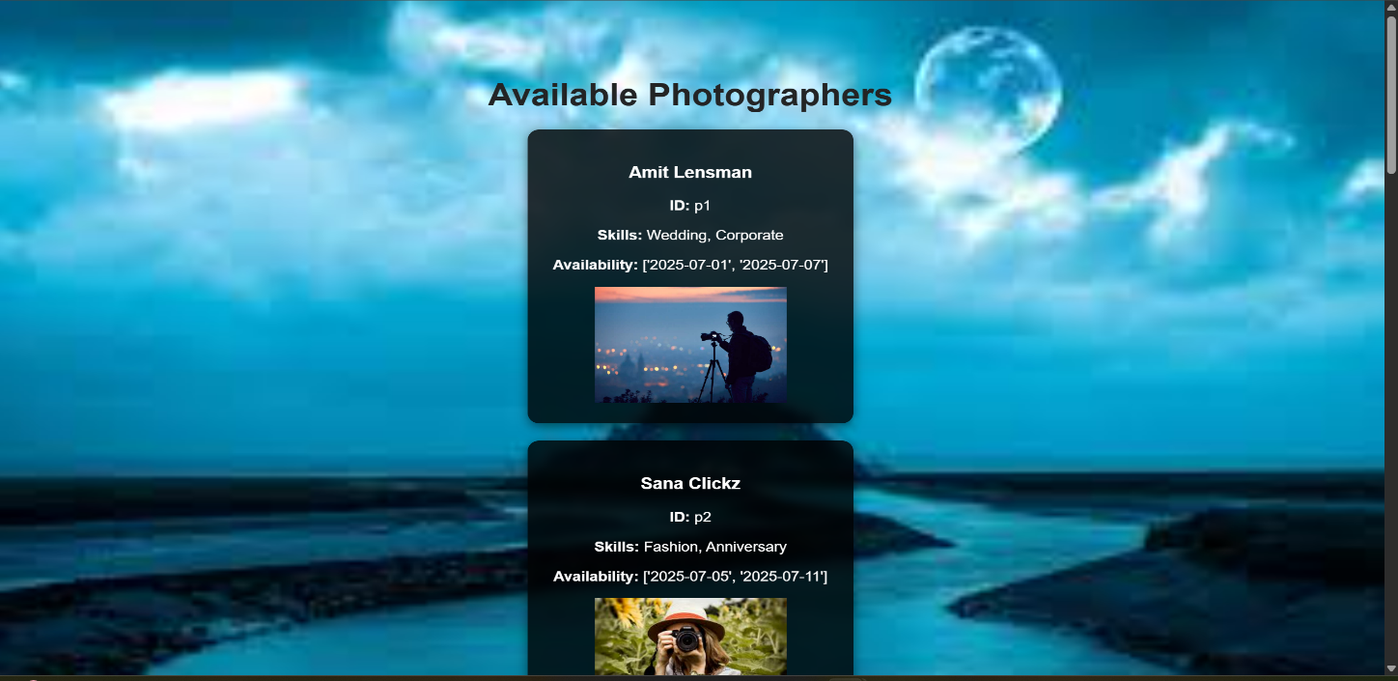

* **Style sample gallery page:**

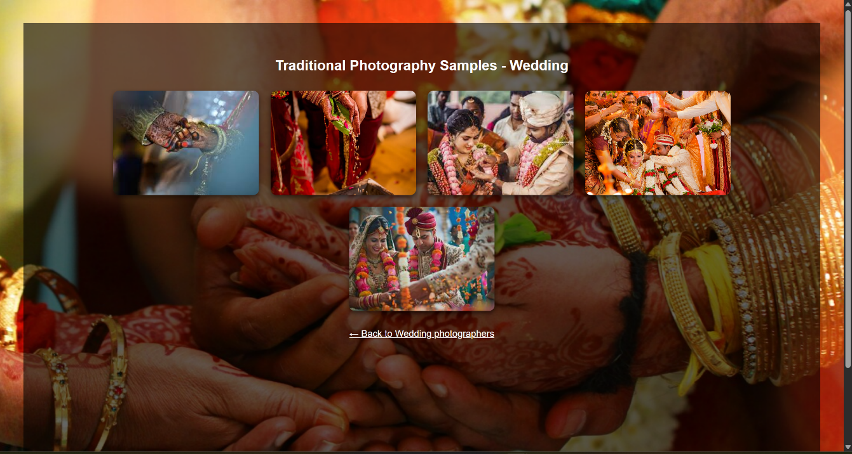

**Exit:**

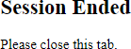

**Dynamodb Database updations :**

1. **Users table :**

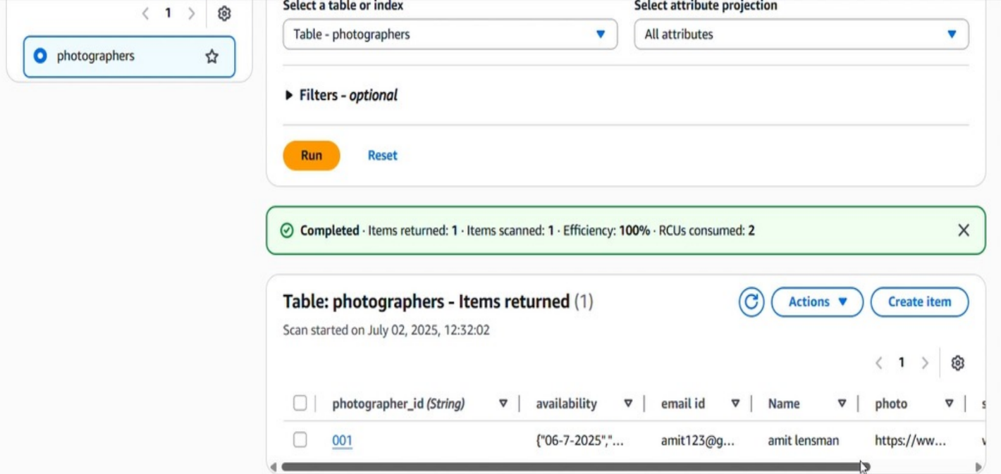

**Conclusion:**

The *Capture Moments* platform has been successfully developed and deployed to streamline the process of

booking professional photographers for various events. Built using Flask and integrated with AWS services

such as EC2 for deployment and DynamoDB for scalable data handling, the system ensures a reliable and user-friendly experience for clients and photographers alike.

This solution addresses the real-world need for a centralized platform where users can seamlessly explore

event types, view sample photography styles, and book available photographers based on their preferences

and availability. With features like secure user login, dynamic event galleries, personalized booking, and availability tracking, the platform significantly improves the efficiency of the booking process.

The cloud-based architecture ensures scalability and responsiveness, allowing the system to handle increased

user demand without compromising performance. Rigorous testing across all modules—user authentication,

event selection, booking confirmation, and payment redirection—has ensured smooth and error-free operation.

In conclusion, *Capture Moments* demonstrates how modern web technologies combined with cloud infrastructure can deliver a scalable, interactive, and visually rich platform for photography booking services. It enhances user satisfaction, empowers photographers, and showcases the power of full-stack development in solving real-world service challenges.